

**POLYTECHNIC UNIVERSITY OF THE PHILIPPINES**

**COLLEGE OF ENGINEERING**

**COMPUTER ENGINEERING DEPARTMENT**

Electives 3

POP QUIZ CHALLENGE

Team Solid

Delos Santos, Alvin T.

Mirano, Miguel T.

Nieva, John Viane C.

Tan, Janine G.

Instructor

**Engr. Frank Anthony Chin**

2017

**Detailed Description:**

“POP QUIZ CHALLENGE” is a quiz application game that records how fast a player can answer all different general information questions available until he respond incorrectly. Also, it allows the user to contribute questions that other players can answer too.

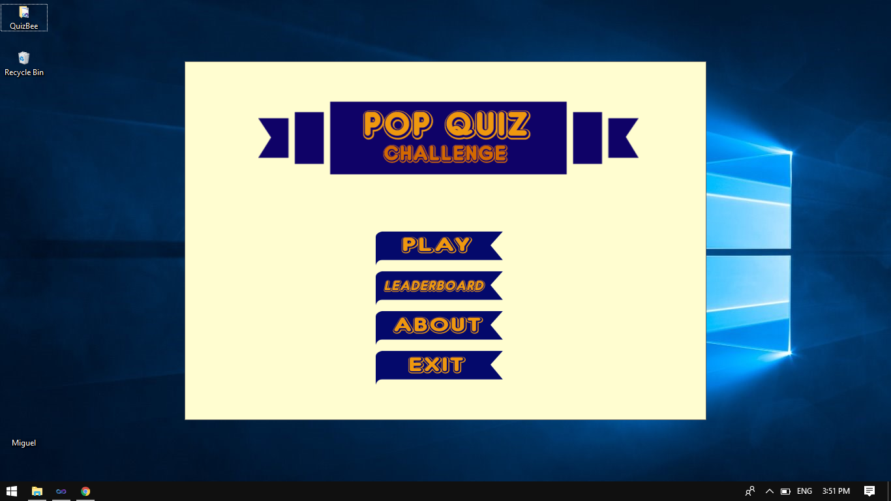

**Main Menu**

**Screen**

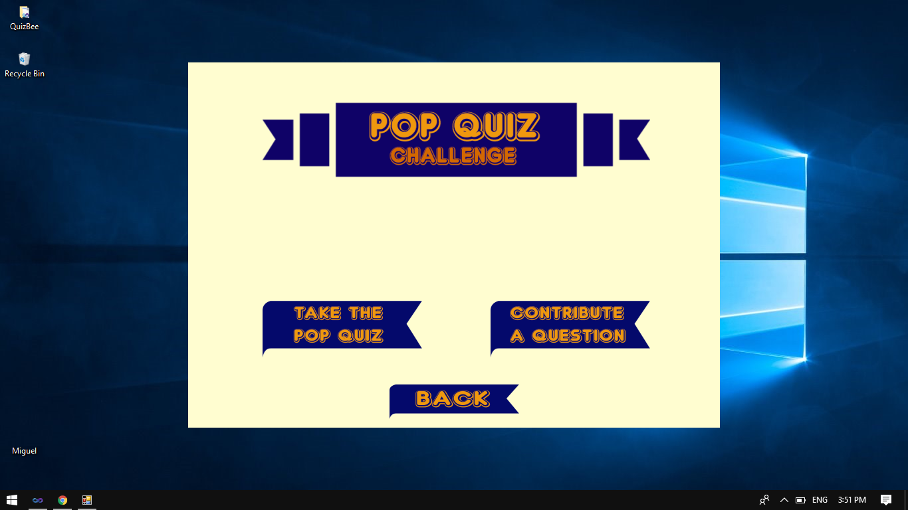

**Play Button**

**Menu**

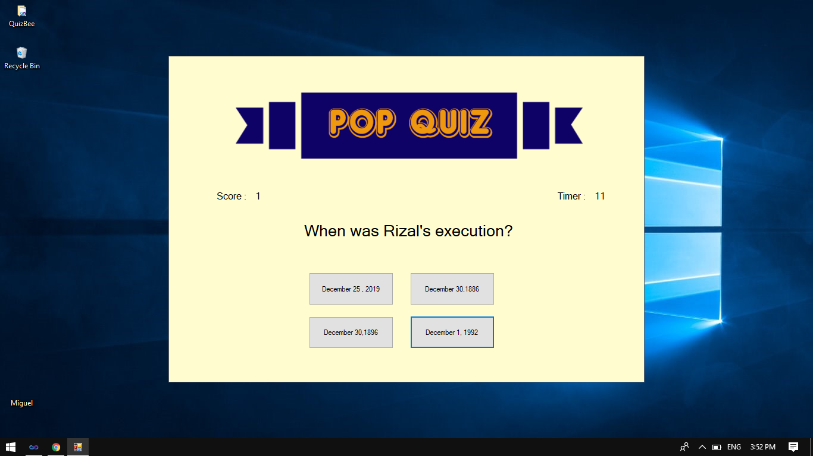

**MAin game**



**question**

**contributing**

**window**

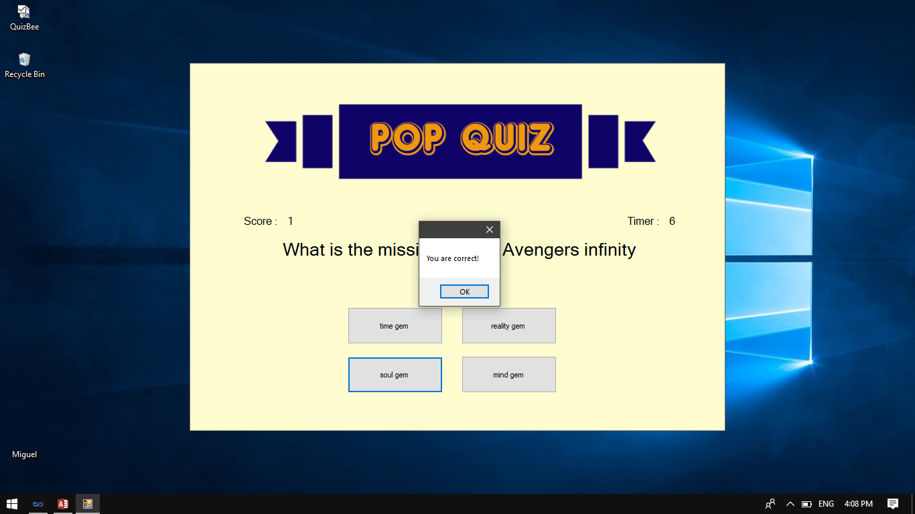

**ANSWER CORRECT**

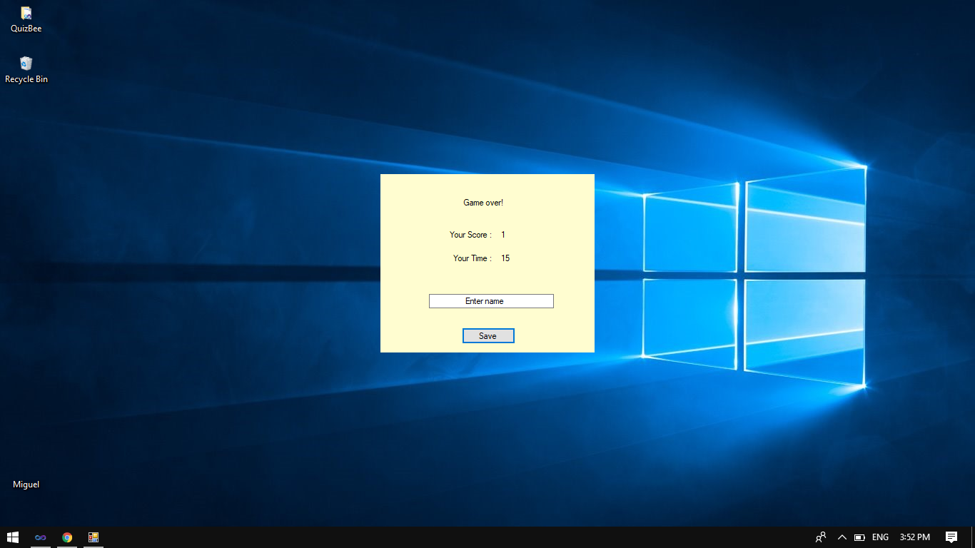

**answer INcorrect**

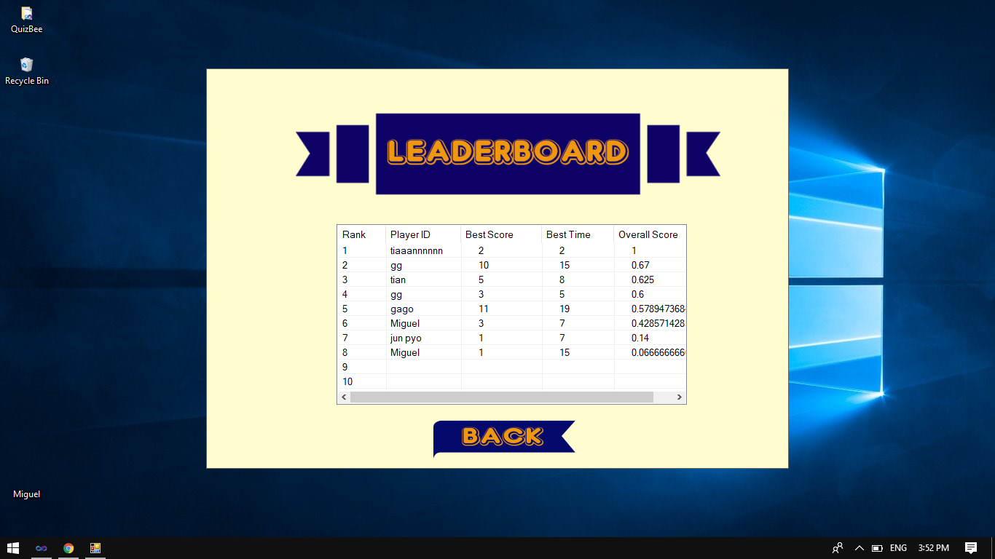

**LeaderboarD**

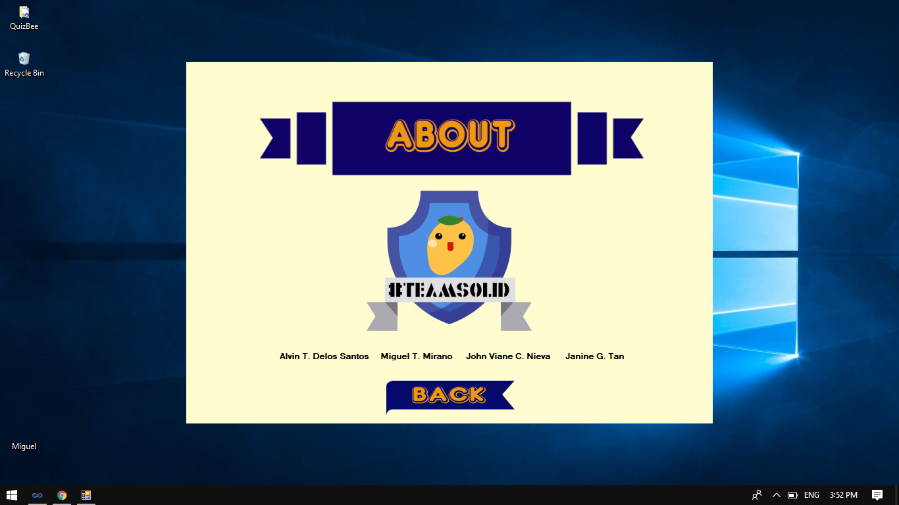

**about page**

**FLOWCHART**

YES

SAVE

BACK

NAME

SAVE

MAIN MENU

PLAY

TAKE THE QUIZ

NO

CONTRIBUTE A QUESTION

BACK

QUESTION

NO

QUESTION

YES

BACK

ABOUT

BACK

LEADERBOARD

EXIT

MAIN MENU

CORRECT?

DECISION

ANSWER